Flowers Class Curriculum Newsletter
Spring 2026
Welcome to Flowers Class!
Adults in class will be Miss Hurley and Mrs Tuplin!
Our Spring Term Topic
‘Coastline’
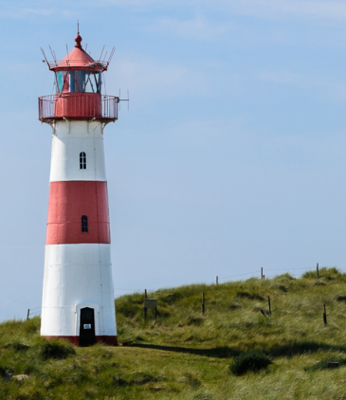
This project teaches your child about the physical and human features of coastal regions across the United Kingdom, including a detailed exploration of the coastal town of Whitby, in Yorkshire. We will compare this to our local town of Skegness. We will be exploring the dangers the coast can bring and look at the work carried out by the RNLI charity to see what they do and how they save lives!
We will then use what we have learnt to design a coastal town that tourists would want to visit, thinking about its location, physical and human features and how to advise visitors to stay safe during their visit.

English
In English this term, the children will be exposed to a variety of texts and film clips as a stimulus for writing. Our focus for writing will be on sentence structure and sentence types, building up to write narratives and non-fiction texts.
Grammar will be taught through Active English sessions, where the children will learn about different word types: noun, adjective, verb, adverb and co-ordinating conjunctions and how they are used within a sentence.
Year 2 children will begin Active Spelling, where they will build strategies to support them with spelling and identify parts of a word (prefix, root, suffix).

Reading
Children will be provided with one reading book via the Jolly Phonics scheme, and they will have an opportunity to choose a library book. Please add to the Reading Log when your child has read their book.
If your child has read their reading book and they need changing this will be done on a Monday. Library books will be changed on a Tuesday.
Please ensure your child brings their reading book to school every day.

Science
This term the children will be learning about- animals including humans. The children will identify, name, draw and label the basic parts of the human body and say which part of the body is associated with each sense. They will then explore that animals, including humans, have offspring which grow into adults and be able to describe the basic needs of animals, including humans, for survival. This will then lead onto them being able to describe the importance for humans of exercise, eating the right amounts of different types of food, and hygiene.
Maths
During the Spring term our Maths will focus on Addition and Subtraction, Multiplication and Division, Length and Height. Year 1 will also revisit Place Values as they understand numbers to 50.
Year 1 | Year 2
Addition and Subtraction  - Understand and use signs for addition (+), subtraction (-) and equals (=).  - Use number bonds and related facts up to 20.  - Add and subtraction one-digit and two-digit numbers to 20.  - Solve one-step problems and missing number problems. | Addition and Subtraction  - Solve addition and subtraction problems.  - Use addition and subtraction facts up to 100.  - Add and subtract numbers mentally and use pictures or objects.  - Show addition can be done in any order but subtraction cannot.  - Use inverse relationships between addition and subtraction.
Place Value  - Read, write and count numbers up to 50.  - Use objects and pictures to represent and identify numbers.  - Use language like equal to, more than, less than, most and least. | Multiplication and Division  - Recall and use multiplication and division facts for the 2, 5 and 10 multiplication tables.  - Calculate mathematical statements for multiplication and division and write them using the multiplication (×), division (÷) and equals (=) signs.  - Show that multiplication of 2 numbers can be done in any order (commutative) and division of 1 number by another cannot.  - Solve problems involving multiplication and division.
Multiplication and Division
- Solve one-step problems involving multiplication and division, by calculating the answer using concrete objects, pictorial representations and arrays.
Length and Height  - Compare, describe and solve practical problems for lengths and heights [for example, long/short, longer/shorter, tall/short, double/half]  - Measure and begin to record lengths and heights. | Length and Height  - Choose and use appropriate standard units to estimate and measure length and height in any direction (m/cm) using rulers and scales.  - Compare and order lengths using >, < and =

PE
Our PE days are Wednesday and Thursday. We will try to hold all PE sessions outside during term one however, it may be necessary to sometimes come indoors. Please send your child in their PE kit.

