Year 5 and 6 Spring Newsletter

Welcome to Year 5 and 6. I hope you all have a lovely break and are all looking forward to the exciting things we have planned for the children next term. I certainly am!

The adult working with your child this year will be:
Class Teacher: Mrs. Reeson

Below you will find information about the topics and areas of the curriculum we will be covering this term and general information about PE and homework.


Frozen Kingdoms
In the Frozen Kingdoms project, your child will learn about the regions of the Arctic and Antarctic. They will learn about the similarities and differences between these two regions, including the climate, landscape and natural resources. They will learn how to use grid references, lines of latitude and longitude, contour lines and symbols to identify the geographical locations of the Arctic and Antarctic, and how these, along with the tilt of the Earth, affect day length and warmth. They will investigate polar oceans to learn how they differ from other oceans on Earth and how climate change increases Earth's temperature and leads to rising sea levels. They will learn about the indigenous people of the Arctic, including how their lives have changed over time, and about the positives and negatives of tourism in Antarctica. They will also learn about classifying animals, animal adaptations and evolution, and polar exploration and discovery.
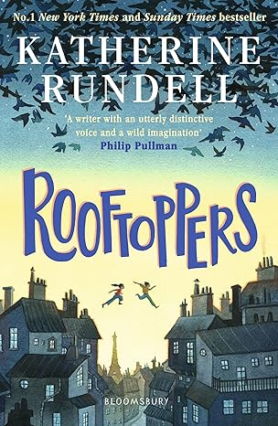
English
Our English lessons will be taught using the following book: The Rooftoppers by Philip Pullman. We will be diving in and creating newspaper report, diary entry, letter & witness statements! This will enable the children to incorporate all those wonderful features and grammatical elements that they have been learning over the last 12 weeks!

Active English & Active Spellings
Spelling - The children will have a set of spellings to focus on each week, during Active Spellings lessons. They will be working on these during different lessons in the week.
Grammar - This term we will be focusing on figurative language, parenthesis, relative clauses and recapping grammar taught in your child’s previous school year to enable them to become more confident when applying these to their writing.

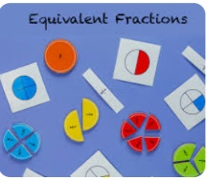
Maths
During Spring term 1 the children will be learning Multiplication and Division. This includes how to multiply and divide using a range of different written and mental methods. This will include long multiplication and division - wow!

PE
Our PE for all Y5 and Y6 children is on Thursday. Please can you send your child to school in their school PE kit every Thursday unless we send a message to say otherwise. PE kit is a burgundy T-shirt and black shorts. We will be outside most of the time, so please send your child in suitable footwear ie. trainers rather than plimsolls, as these can be slippery on the grass. Leggings or joggers can be worn when the weather becomes colder.

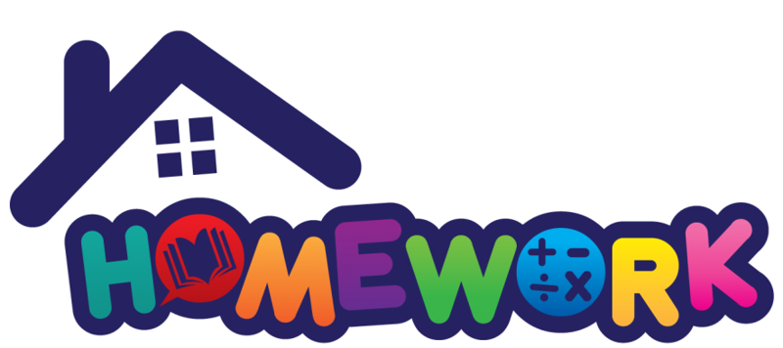
Your child will be given a homework sheet with several maths/English related questions each week. These will be handed out every Friday and expected in by the following Friday.
Please also continue to read with your child and complete the Home/School reading record as Bee rewards are given to celebrate reading. Your child should aim to read at least 3 times a week for a minimum of 10 minutes each time. It is also beneficial to ask your child questions about what they have read and discuss the text as this will develop their understanding and love of reading. If you would like any advice on this, please ask.

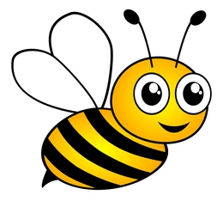
Rewards
We love to celebrate good work, fantastic effort, displays of perseverance, a good attitude to learning, manners and respectful behaviour and many more. To recognise this, we use ‘Bees’ to help promote this. These bees then get added to the class Bee draw, which will be done at the end of each week. We look forward to celebrating each week with your children.

Thank you in advance for your support.
Mrs Reeson

