KS1 Long Term Curriculum Overview Cycle B

Y1/2 Cycle B | Driver project |  | 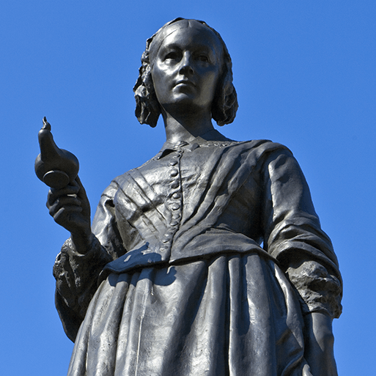  Movers and Shakers |  | 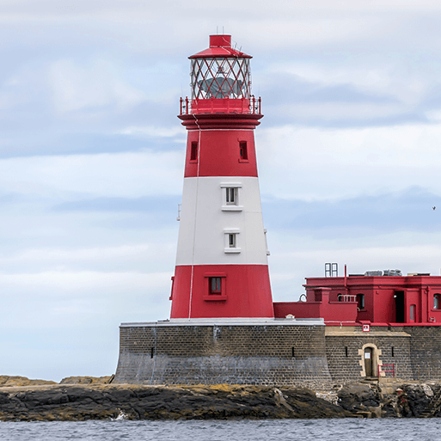  Coastline |  | 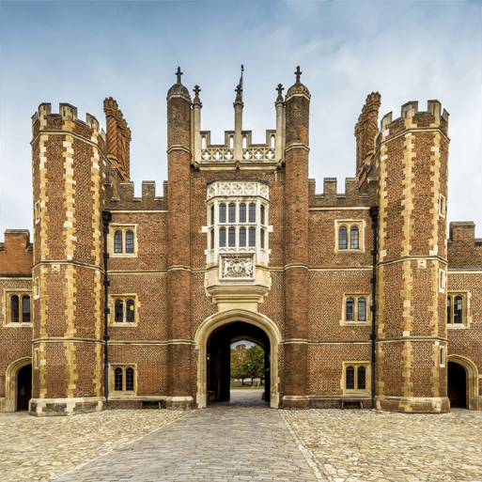  Magnificent Monarchs
Y1/2 Cycle B | English |  | Poetry: Free Verse  Narrative: Owl Babies, George and the Dragon, | Narrative: The Storm Whale, Marshmallows, the Bear and the Hare | Poetry: Performance  Narrative: Little Boat, The Boy Who Sailed the World  Instructions: Pancakes | Poetry: Poetry for Art  Narrative: The Lighthouse Keeper’s Lunch  Recount: RNLI
Y1/2 Cycle B | Subject-specific projects | Geog | Let's Explore the World |  | Coastline |  | Revision and retrieval practice
Y1/2 Cycle B | Subject-specific projects | Science | Materials |  | Animals including humans |  | Living things and their habitats
Y1/2 Cycle B | Subject-specific projects | Art | Exploring Colours | Still life | Flower Head |  | Portraits and poses
Y1/2 Cycle B | Subject-specific projects | DT | Remarkable recipes |  | Beach Hut |  | Cut, Stitch and Join / Push and Pull
Y1/2 Cycle B | Subject-specific projects | RE | What do stories from religious traditions teach about God?  What can we learn from other stories? |  | What do creation stories teach people about God and human nature? |  | What are sacred texts and why do they matter?
Y1/2 Cycle B | Subject-specific projects | Music | Dynamics (Seaside) | Sound patterns (Fairy tales) | Call and Response (Animals) | Musical symbols (Under the sea) | Contrasting Dynamics (Space) | Structure (Myths and Legends)
Y1/2 Cycle B | Subject-specific projects | PSHE | Being me in my world | Celebrating Difference | Dreams and Goals | Healthy Me | Relationships | Changing Me
Y1/2 Cycle B | Subject-specific projects | Comp | National Centre for Computing – Year 2
Y1/2 Cycle B | Subject-specific projects | Maths | White Rose Maths (Y1+Y2 Autumn) |  | White Rose Maths (Y1+2 Spring) |  | White Rose Maths (Y1+2 Summer)

