Y3/4 Cycle B | Driver project |  | 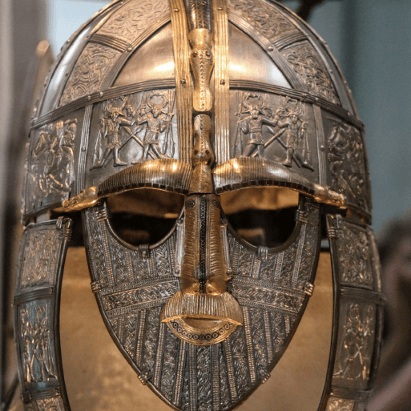  Invasion |  |   Misty Mountain, Winding River |  |  |  |  | 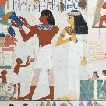  Ancient Civilisations
Y3/4 Cycle B | English |  | Poetry: Haiku  How to be a Viking  How to train your dragon | Poetry:Free verse  Tuesday  Christmas unit | Poetry: Simile and metaphor poetry  The Ice Palace  Journey |  |  | Poetry through Hello Lighthouse  Hello Lighthouse |  | Poetry: Whole school poetry: Where the Forest Once Stood.  Iron Man |  | Poetry through Nightbus Hero planning  The Nightbus Hero
Y3/4 Cycle B | Guided Reading Book |  | How to Train your Dragon | The Ice Palace | Varjak Paw |  |  | The Iron man |  | The Nightbus Hero |  | The Egyptian Cinderella
Y3/4 Cycle B | Subject-specific projects | Geog | Interconnected world |  | Misty Mountain, Winding River |  |  |  |  | Revision and retrieval
Y3/4 Cycle B | Subject-specific projects | Science | Light | Living things and their habitats | Electricity |  |  | Group classifications |  | States of matter |  | Plants
Y3/4 Cycle B | Subject-specific projects | Art | Warm and cool colours – colour mixing |  | Vista – techniques used to compose landscapes |  |  |  |  | Statues, statuettes and figurines – figure drawing
Y3/4 Cycle B | Subject-specific projects | DT |  | Fresh Food, Good Food – food preservation and decay; healthy snacks |  |  |  |  | Functional and Fancy Fabric – design and make a William Morris-style fabric |  |  | Tomb builders – simple machines using wheels, pulleys and levers
Y3/4 Cycle B | Subject-specific projects | RE | How do people welcome  new life into the world? | How do people show their commitment to a religion? | How do people celebrate marriage? |  |  |  |  | What do people believe about the afterlife?  How is this expressed in funeral practices?
Y3/4 Cycle B | Subject-specific projects | Music | Creating a composition in response to an animation (Theme: Mountains) | Rock and Roll | Ballads |  |  | Haiku, music and  performance  (Theme: Hanami festival) |  | Changes in pitch, tempo  and dynamics  (Theme: Rivers) |  | Samba and carnival sounds  and instruments  (Theme: South America)
Y3/4 Cycle B | Subject-specific projects | PSHE  Jigsaw | Being Me- In My World | Celebrating Difference | Dreams and Goals |  |  | Healthy Me |  | Relationships |  | Changing Me
Y3/4 Cycle B | Subject-specific projects | French-Language Angels | Phonics  Les Instruments |  |  | Les Saisons | Les glaces |  |  |  | Les vêtements | Au salon du thê
Y3/4 Cycle B | Subject-specific projects | Comp | National Centre for Computing – Y4
Y3/4 Cycle B | Subject-specific projects | Maths | White Rose Maths (Y3+Y4 Autumn) |  | White Rose Maths (Y3+4 Spring) |  |  |  |  | White Rose Maths (Y3+4 Summer)

