Y5/6 Cycle B | Driver project |  | 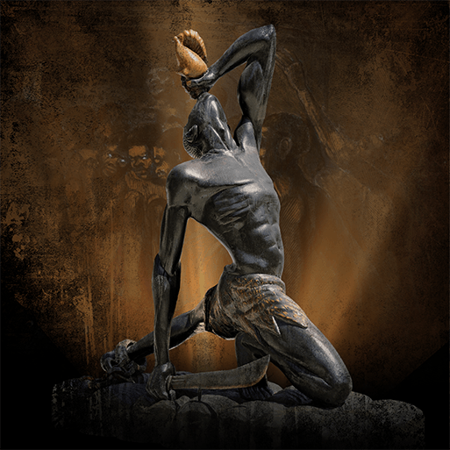  Maafa |  |  | 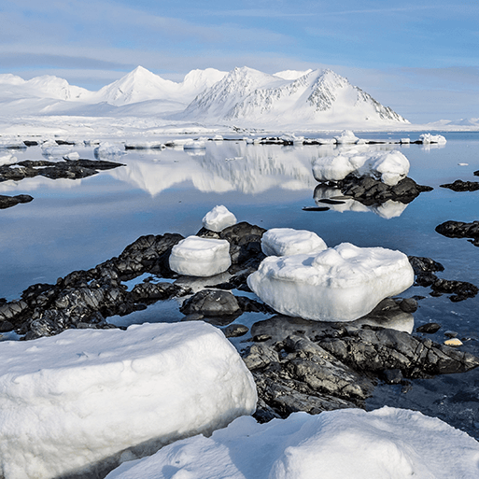  Frozen Kingdom |  |  | 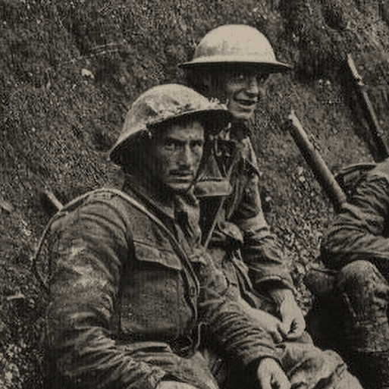  Britain at War
Y5/6 Cycle B | English Book |  | Everest -Alexander Stewart |  | The Lighthouse  The Christmas Miracle of | Rooftoppers | Julius Caeser |  | Letters from the Lighthouse | Clockwork
Y5/6 Cycle B | Guided Reading Book |  | The boy at the back of the class – Onjali Q. Rauf |  | Rooftoppers- Katherine Rundell | How to live forever -Colin Thompson | Letters from the Lighthouse |  | Clockwork-Philip Pullmao | Brainstorm -Vasti Hardy
Y5/6 Cycle B | Subject-specific projects | Geog | Our Changing World |  |  | Covered in Driver project |  |  | Geography revision and retrieval practice
Y5/6 Cycle B | Subject-specific projects | Science | Space |  |  | Electrical circuits and components(Y6)  Living things and their habitats (Y6)- |  |  | Light theory(Y6) |  |  | Evolution and inheritance (Y6)
Y5/6 Cycle B | Subject-specific projects | Art | Tints, Tones and Shades |  | Trailblazers, Barrier Breakers | Inuit | Environmental Artists |  | Distortion and Abstraction |  |  | Bees, Beetles and Butterflies
Y5/6 Cycle B | Subject-specific projects | DT | Food for Life |  |  | Engineer |  |  | Make Do and Mend
Y5/6 Cycle B | Subject-specific projects | RE | How do people know who or what to believe? (Y6) | What do people believe about the existence of God? (Y6) |  | What do people believe about good, evil and suffering? (Y6) |  |  | What do we mean by religious and spiritual experiences? (Y5 topic) |  | What do we believe about peace?
Y5/6 Cycle B | Subject-specific projects | Music  Kapow | Looping and Mixing | Blues |  | Dynamics, Pitch & Texture (coastal theme) |  | Composition to represent the festival of colour | South and West Africa |  | Composing and performing a leavers song.
Y5/6 Cycle B | Subject-specific projects | PSHE  Jigsaw-Y6 | Being Me | Celebrating Difference |  | Dreams and Goals |  | Healthy Me | Relationships |  | Changing Me
Y5/6 Cycle B | Subject-specific projects | French  Language Angels | Je Me Presente | La famille |  | Chez Moi |  | As-tu un animal? | Habitats
Y5/6 Cycle B | Subject-specific projects | Comp | National Centre for Computing Y6
Y5/6 Cycle B | Subject-specific projects | Maths | White Rose Maths (Y5+Y6 Autumn) |  |  | White Rose Maths (Y5+6 Spring) |  |  | White Rose Maths (Y5+6 Summer)

