Flowers Class Curriculum Newsletter
Summer 2026
Welcome to Flowers Class!
Adults in class will be Miss Hurley and Mrs Tuplin
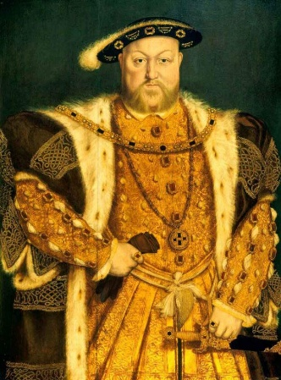
Our Summer Term Topic
‘Magnificent Monarchs’
In the Magnificent Monarchs project, your child will learn about English and British Monarchs from AD 871 to the present day and consider how the power of the monarchy has changed over time. They will study significant sovereigns including Alfred the Great, William the Conqueror, Henry VIII, Elizabeth I, Queen Victoria and Elizabeth II. We will closely at Tudor portraits in art sessions and analyse and compare Tudor portraits and selfies today. They will use photo editing software to create royal portraits.

English
In English this term, the children will continue to be exposed to a variety of texts and film clips as a stimulus for writing. Our focus for writing will be sentence structure and sentence types, building up to write narratives and non-fiction texts.
Grammar will be taught through Active English sessions, where the children will learn about different word types: noun, adjective, verb, adverb and co-ordinating conjunctions and how they are used within a sentence.
Year 2 children will begin Active Spelling, where they will build strategies to support them with spelling and identify parts of a word (prefix, root, suffix).

Reading
Children will be provided with one reading book via the Little Wandle scheme and they will have an opportunity to choose a library book. Please add to the Reading Log when your child has read their book.
If your child has read their reading book and they need changing this will be done on a Monday. Library books will be changed on a Tuesday.
Please ensure your child brings their reading book to school every day.

Science
This term the children will be learning about “Living things and their habitats”. The children will explore habitats in our local area and identify that most living things live in habitats to which they are suited and describe how different habitats provide for the basic needs of different kinds of animals and plants, and how they depend on each other. They will then find out about other habitats including deserts, woodland and the ocean.
They will describe how animals obtain their food from plants and other animals, using the idea of a simple food chain, and identify and name different sources of food. As well as explore and compare the differences between things that are living, dead, and things that have never been alive.
Maths
During the Summer term our Maths will focus on money, fractions, time, statistics, position and direction. Year 1 will also revisit Place Value as they understand numbers to 100.
Year 1 | Year 2
Money  - recognise and know the value of different denominations of coins and notes | Money  - recognise and use symbols for pounds (£) and pence (p); combine amounts to make a particular value  - find different combinations of coins that equal the same amounts of money  - solve simple problems in a practical context
Fractions  - recognise, find and name a half as 1 of 2 equal parts of an object, shape or quantity  - recognise, find and name a quarter as 1 of 4 equal parts of an object, shape or quantity | Fractions  - recognise, find, name and write fractions 1/3, ¼, 2/4, 3/4 of a length, shape, set of objects or quantity  - write simple fractions, for example ½ of 6 = 3  - recognise the equivalence of ½ and 2/4
Place Value  - count to and across 100, forwards and backwards, beginning with 0 or 1, or from any given number  - count, read and write numbers to 100 in numerals; count in multiples of 2s, 5s and 10s  - given a number, identify 1 more and 1 less | Statistics  - interpret and construct simple pictograms, tally charts, block diagrams and tables  - ask and answer simple questions by counting the number of objects in each category and sorting the categories by quantity
Time  - Measure time (hours, minutes, seconds)  - sequence events in chronological order  - recognise and use language relating to dates, including days of the week, weeks, months and years  - tell the time to the hour and half past the hour and draw the hands on a clock face to show these times | Time  - compare and sequence intervals of time  - tell and write the time to five minutes, including quarter past/to the hour and draw the hands on a clock face to show these times  - know the number of minutes in an hour and the number of hours in a day
Position and Direction  - describe position, direction and movement, including whole, half, quarter and three-quarter turns | Position and Direction  - order and arrange combinations of mathematical objects in patterns and sequences  - use mathematical vocabulary to describe position, direction and movement, including movement in a straight line and distinguishing between rotation as a turn and in terms of right angles for quarter, half and three-quarter turns (clockwise and anti-clockwise)

PE
Our PE days are Wednesday and Thursday. Swimming sessions will take place on the first 6 Wednesdays of the summer term. Please ensure swimming kits are brought to school.
Please send your child in their PE kit.

