Flinders Class Newsletter
Term dates: Tuesday 21st April - Friday 22nd May 2026
Flinders Staff: Mrs. Morris and Mrs. Falkner.

Below you will find some information about the topics and areas of the curriculum we will be covering this term and some general information about PE and homework.

English
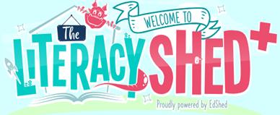
Beginning the term will be a short unit of poetry with an environmental theme to build on our previous learning of poetic techniques. We will be looking at story writing, including character and setting descriptions through the text ‘The Iron Man’ by Ted Hughes. Our Guided Reading text is ‘The Night Bus Hero’ by Onjali Q. Raúf. We will continue growing our grammar knowledge through our Active English lessons and to develop our knowledge of spelling patterns through daily Active Spelling sessions.

Maths
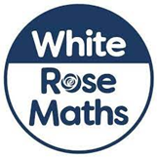
Our Maths lessons this term will complete our work on fractions We will then do some work on time before moving on to decimals. We regularly practise multiplication facts and number bonds to improve rapid recall of number facts. We will continue to use fun, hands-on learning approaches to support the children’s understanding as they progress through the various Maths units.

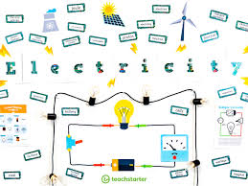
Science
Our Science topic this term is States of Matter exploring how materials can be categorised as solids, liquids or gases and how the materials can change state. There will be lots of opportunities for practical work investigating heating, cooling and melting and trying to make our own water cycles.

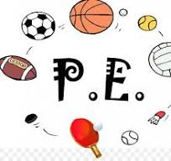
PE
PE for Flinders Class is on Thursday morning. PE is outside this term with lots of practice for Sports Day. Please ensure your child has suitable footwear and is wearing the correct PE uniform – burgundy or white T-shirt and dark shorts/leggings.

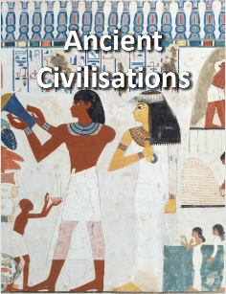
Ancient Civilisations (Topic)
Throughout the Summer term, we will be learning about the history of three of the world’s first ancient civilisations: ancient Sumer, ancient Egypt and the Indus Valley civilisation. We will explore the rise, life, achievements and eventual end of each civilisation.

Homework
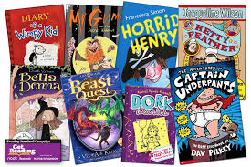
All children should read a minimum of three times per week. Please ensure that this reading is logged onto the digital record (Learning with Parents) as it allows staff to keep track of what the children are enjoying. Reading aloud with your child is a lovely way to spend a few minutes and it gives them the chance to discuss their book with you, plus ask about any unfamiliar vocabulary. Research shows that children’s understanding of what they read improves significantly in line with their ease of reading fluently aloud. Reading is a vital life skill and the more your child reads, the better they can access all their learning across the curriculum.

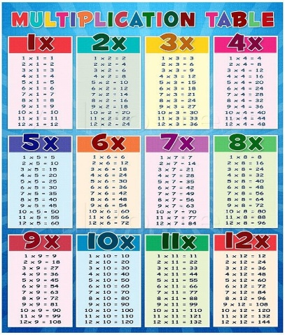
Times tables practice is another area where you can help your child with their learning. Children should practise their tables for a few minutes every day to embed them in their long-term memory and facilitate rapid recall.
Multiplication Tables Check - Mathsframe is a free website where children can practise for the Statutory Multiplication Check which Y4 will be taking during the second week of June 2026. The site replicates the conditions of the MTC with 25 questions each on a six-second timer. The better the children know all their tables up to 12 x12, the easier they will find this check. There are also lots of free, fun apps available using games and songs which is a great way to help facts ‘stick’ in the memory.

Summer weather
Please ensure your child has a named water bottle in school every day as the classroom gets very warm in the afternoons. Children are welcome to bring a hat and suncream although it is helpful if they/you can apply a layer at home before school.

Should you have any questions or concerns about your child’s learning, I am always available for a quick chat at the beginning or end of the day, or you can email via the school office enquires@partney.lincs.sch.uk marked FAO Mrs. Morris in the Subject line.

Many thanks, Emma Morris

